**ASSIGNMENT 11.1**

1) Perform and explain the code flow and the associated result for the below tasks. Candidates should create and use their own employee dataset for the same.

**Transfer data between MySQL and HDFS (Import and Export) using Sqoop.**

i) Import the ‘employee’ data from MySQL to HDFS.

Step 1:

Open the MySQL server

Create the new database in the mysql instance.

Output:



Step 2:

Create a table and insert the values in mysql instance which is created in the database.

Output:





Step 3:

Since the data is present in MySQL and Sqoop is up and running, we will fetch the data from the following command:

Output:

sqoop import --connect jdbc:mysql://localhost/db1 –username root --table emp1 –target-dir /user/acadgild/emp1

Step 4:

Let’s check whether any data is stored in HDFS. This can be done by using the following command:

hadoop fs -ls /user/acadgild/emp1

hadoop fs -cat /user/acadgild/emp1/*

Output:

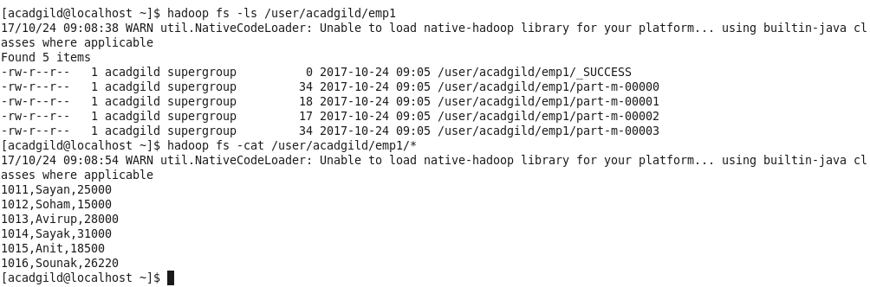

Thus, in the above ways the data is imported successfully in HDFS from MySQL.

ii) Export the ‘employee’ dataset from HDFS to MySQL.

Step 1:

Open the MySQL server

Create a new database from the mysql instance.

Output:



Step 2:

Create a table in the database from mysql instance

Output:

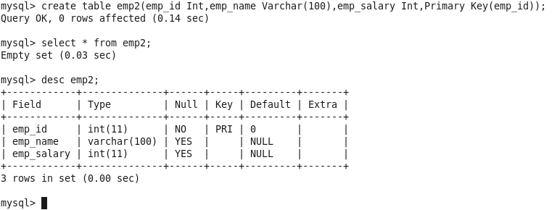

Step 3:

After that we will export the data from HDFS to MySQL using the following command:

sqoop export -m 1 --connect jdbc:mysql://localhost/db1 --username root --table emp2 --export-dir /acadgild/

Output:



Step 4:

We will now check in MySQL the data is exported.

Output:

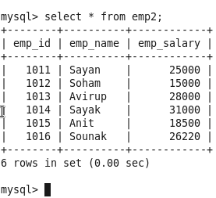

Thus, in the above ways we are able to export the data from HDFS to MySQL successfully.

**Transfer data between MySQL and Hive (Import and Export only selected columns) using Sqoop.**

i) Import the data from MySQL to Hive.

Step 1:

Open the MySQL server

Create the new database in the mysql instance.

Output:

mysql> create database emp;

mysql> use emp;

Step 2:

Create a table and insert the values in mysql instance which is created in the database.

Output:

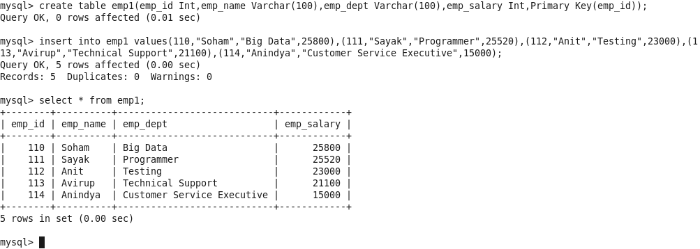

Step 3:

Import the data from MySQL to hive shell using the following command.

sqoop import --connect jdbc:mysql://localhost/emp --username root -m 1 --table emp1 --delete-target-dir --target-dir=/queryresult --hive-import --hive-table emp.employee_details;

Output:



Step 4:

Now we will check the data imported in hive from MySQL to hive.

Output:

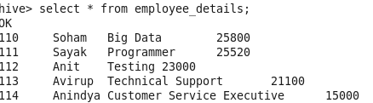

Thus, in the above ways the data is imported successfully in HDFS from MySQL.

(ii) Export the data from Hive to MySQL using the following command:

Step 1:

We have to create a new database in the hive shell.

Output:



Step 2:

Next, we have to create a new table and insert the values in the hive shell.

Output:

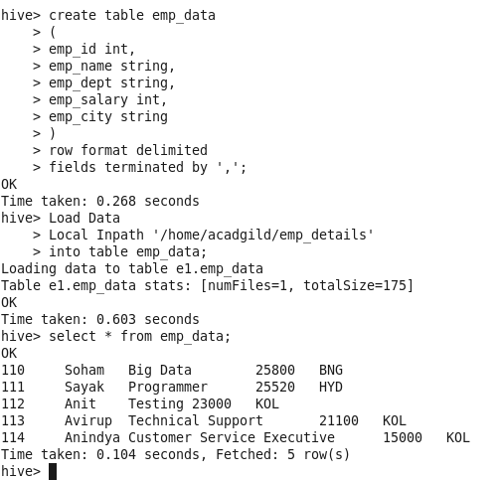

Step 3:

Now, we have to open the MySQL server and create the new database.

Output:

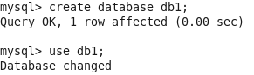

Step 4:

Then, we have to create the table in the database created from the mysql instance.

Output:

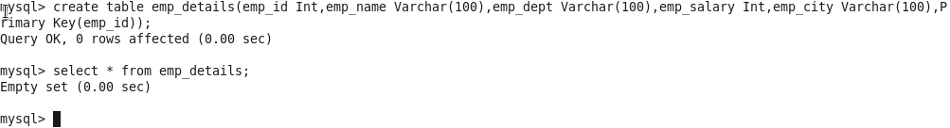

Step 5:

Then we will export the data from hive to mysql using the following command:

Output:



Step 6:

Now we will see the exported data in MySQL.

Output:

